**DAILY ONLINE ACTIVITIES SUMMARY**

|  |  |  |  |  |  |  |
| --- | --- | --- | --- | --- | --- | --- |
| **Date:** | **12 June 2020** | | **Name:** | | **KHATHEEJA SAFREENA.** | |
| **Sem & Sec** | **4th sem, 2nd year** | | **USN:** | | **4AL18CS037** | |
| **Online Test Summary** | | | | | | |
| **Subject** | | **Adalitha kannada** | | | | |
| **Max. Marks** | | **25** | | **Score** | **21** | |
| **Certification Course Summary** | | | | | | |
| **Course** | **INTRODUCTION TO ETHICAL HACKING.** | | | | | |
| **Certificate Provider** | **Great leaning.** | | | **Duration** | | **4 hours** |
| **Coding Challenges** | | | | | | |
| **Problem Statement:1 program** | | | | | | |
| **Status: Executed** | | | | | | |
| **Uploaded the report in Github** | | | | **Yes** | | |
| **If yes Repository name** | | | | [http://shafreenasharief / lockdown-coding](http://shafreenasharief / lockdown-coding" \o "http://shafreenasharief / lockdown-coding)  [http://shafreenasharief / locked-down--certification-course](http://shafreenasharief / locked-down--certification-course" \o "http://shafreenasharief / locked-down--certification-course)  [http://shafreenasharief / Daily\_Report](http://shafreenasharief / Daily_Report" \o "http://shafreenasharief / Daily_Report) | | |
| **Uploaded the report in slack** | | | | **Yes** | | |

Online Test Details: (Attach the snapshot and briefly write the report for the same)

Certification Course Details: (Attach the snapshot and briefly write the report for the same)

Coding Challenges Details: (Attach the snapshot and briefly write the report for the same)

**ONLINE TEST SUMMARY**

**Today kannada exam was conducted in google classroom for 25 marks with duration of 25 min.**

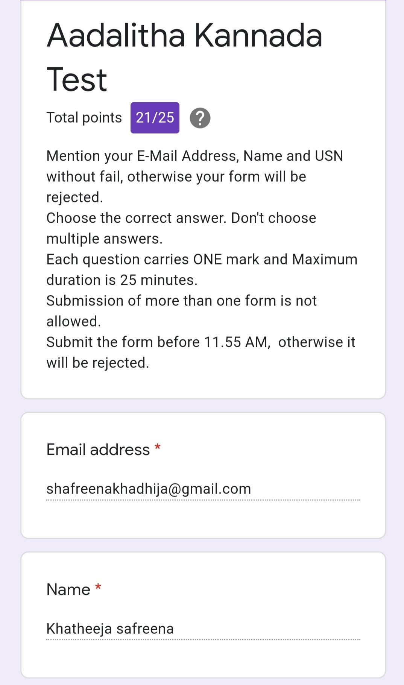

**CERTIFICATION COURSE SUMMARY:**

Today I'm doing a course on **INTRODUCTION TO ETHICAL HACKING** through **GREAT LEANING**. It is a 4 hours course**.** I completed all the module .I attempted quiz ,which gave me a clear veiw about the topics that were thought and discussed.It consists of 6 modules which also include assessments.

I successfully completed certification course and secured e-certificate

The concept covered in the course are as follows:

* Career and Growth ladder in ethical hacking.
* Domain and process implementation in ethical hacking.
* Ethical hacking in Network Architecture-Demonstration.
* Ethical hacking in web Application- Demonstration.
* Ethical hacking in mobile Application-Demonstration.
* What is Ethical hacking?

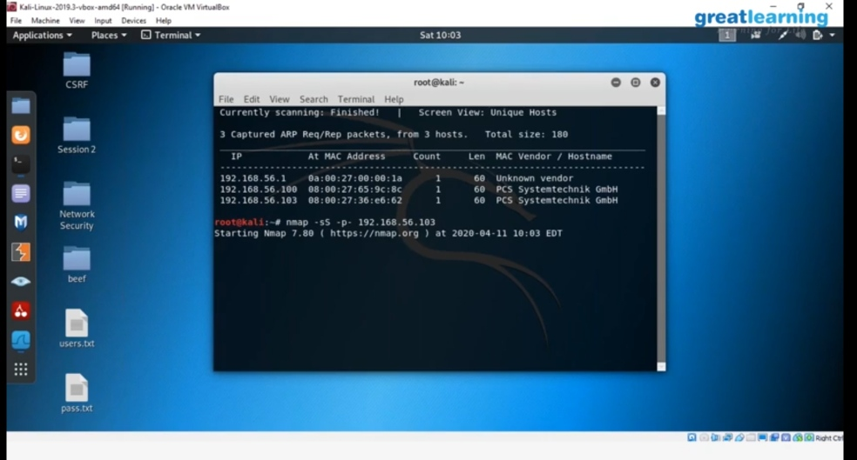

* **There is the snapshot of the certificate.**

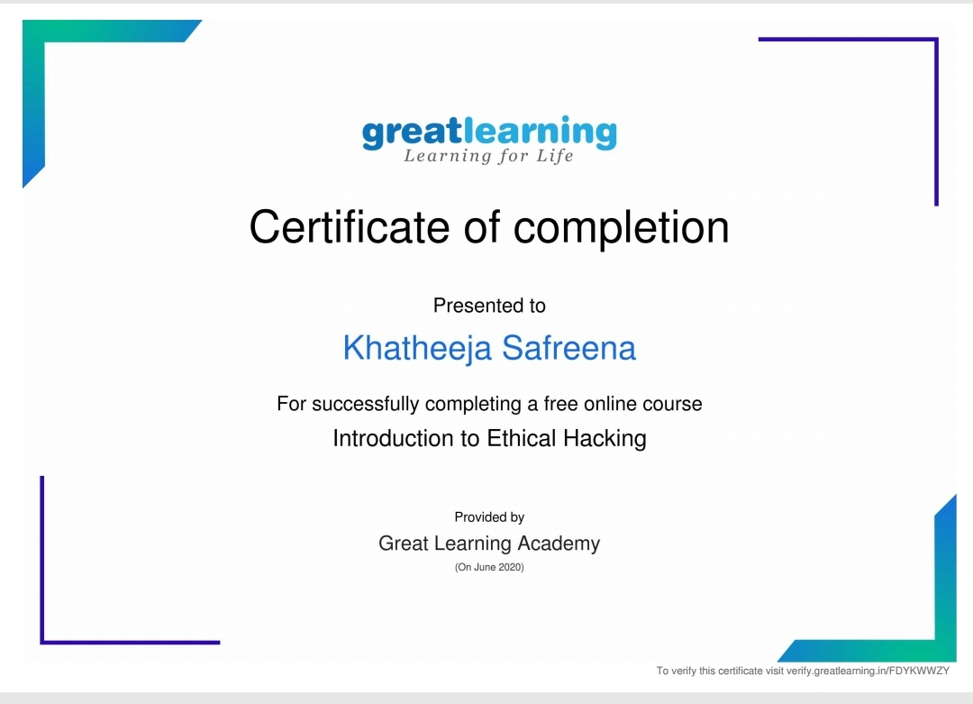

**CODING CHALLENGES**

Today I solved coding challenge,

1. **Given two positive integers start and end. The task is to write a Python program to print all Prime numbers in an Interval.**

**Explanation:** A prime number is a natural number greater than 1 that has no positive divisors other than 1 and itself. The first few prime numbers are {2, 3, 5, 7, 11, ….}. The idea to solve this problem is to iterate the val from start to end using a for loop and for every number, if it is greater than 1, check if it divides n. If we find any other number which divides, print that value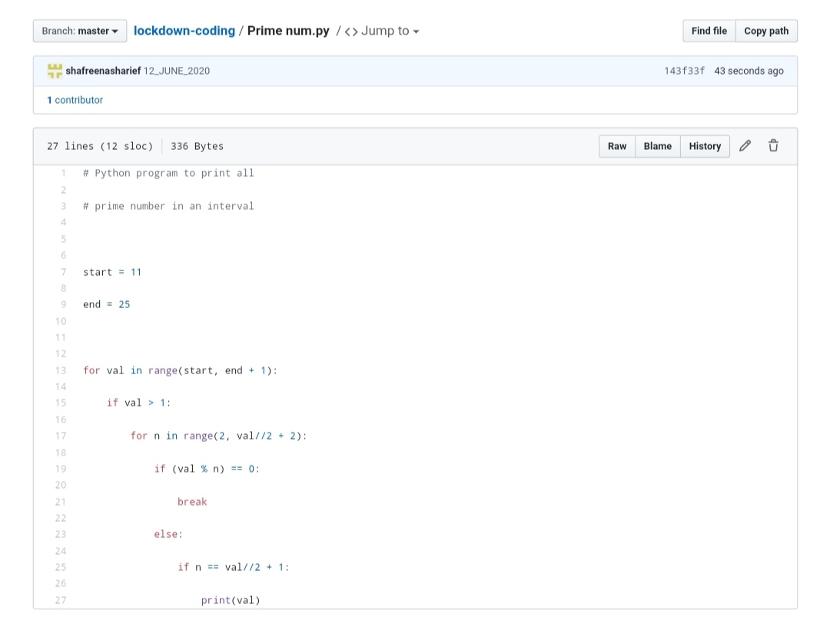

**SOLUTION** : I have uploaded the solution of the above 3 coding problems in my GitHub repository.

http://shafreenasharief / lockdown-coding

http://shafreenasharief / locked-down--certification-course

http://shafreenasharief / Daily\_Report